|  |  |
| --- | --- |
|  |  |

|  |
| --- |
| **Activity 6.2.3a More Resistors** |

Introduction

Resistors come in dozens of sizes and shapes, but they all do the same thing: limit or resist current. The carbon composition fixed resistor is only one of several major kinds of resistors. This activity will introduce you to some other types of resistors found in our everyday lives.

Equipment

* Schematic Symbols Chart
* Engineering notebook
* Various loose resistors
* Snap Circuits® components
* Board, voltage source, and power supply
* Red LED
* Variable resistor (slide potentiometer)
* Photoresistor (photocell)
* Thermistor
* Lamp
* Various sizes of snap wires

Procedure

1. In teams of two, you will learn about other types of resistors. Complete the circuits and engineering journal entries as outlined in the More Resistors presentation.
2. Complete the Schematic Symbols Chart as you learn about different electronic components and functions.

Purpose

The purpose of this lab is to demonstrate the effects of increased resistance in a circuit to the brightness of a light in that circuit, and to show that the same effect can be obtained using a variable resistor.

**Potentiometers**

Also called __Pots_, these resistors change the amount of resistance _Mechanically_. They can be used to alter the volume of a radio or change the brightness of a lamp. Potentiometers equipped with a plastic thumbwheel or a slot for a screwdriver blade are called trimmers. They are designed for occasional adjustment.

Draw a schematic diagram for a series circuit powered by 3 DC volts that contains an LED and a potentiometer.

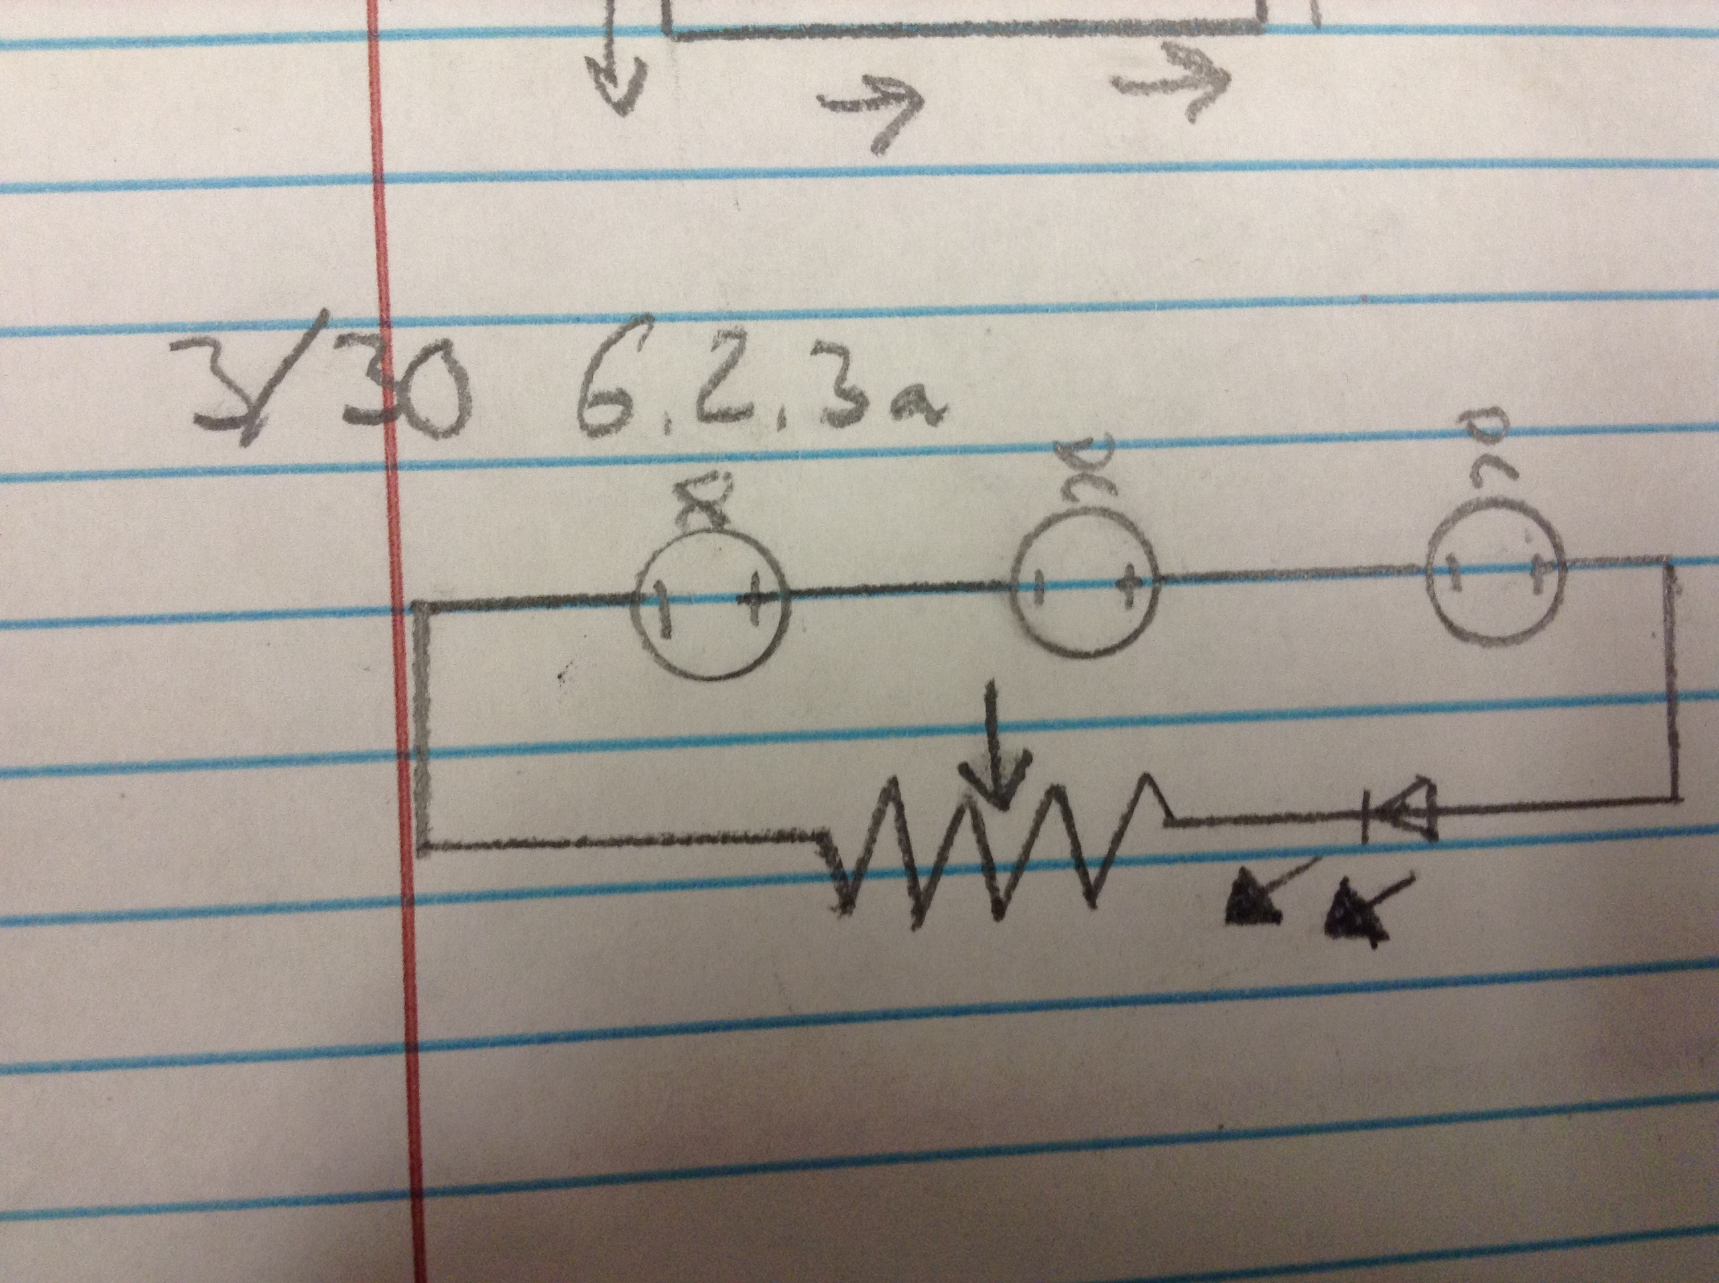

Build your circuit using the Snap Circuits. Power on the circuit and move the potentiometer. **EXPLAIN** what is happening with the LED.

The amount of resistance in the potentiometer is changing, which adjusts the amount of electrons flowing through the LED and can make it brighter, dimmer, or go out.

**Thermistors**

This is a __Temperature Sensitive__resistor. _Increasing_ the temperature _Decreases_ the resistance.

Draw a schematic diagram for a series circuit powered by 3 DC volts that contains an LED and a thermistor.

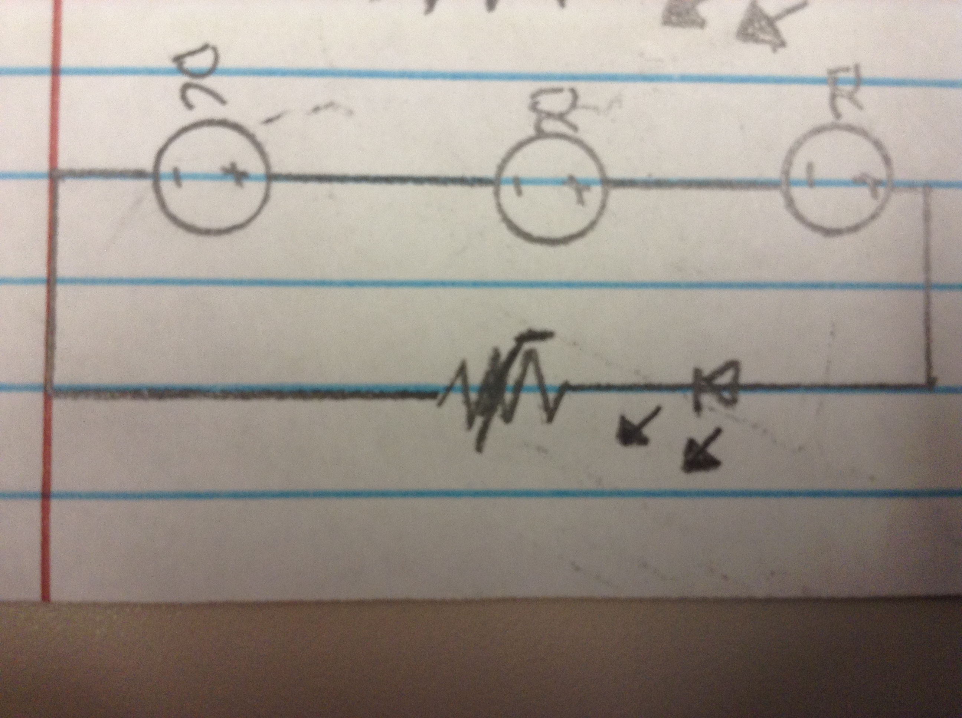

Build your circuit using the Snap Circuits. Use the flexible holder to attach the thermistor. Power on the circuit and using a hair dryer, heat up the thermistor. **EXPLAIN** what is happening with the LED.

The LED gets brighter as the thermistor gets warmer, making it less resistive.

**Photoresistors**

Also called _Photocell_, these resistors are made from a light sensitive material. When light is _Bright_, resistance is _Low_. When light is _Dark_, resistance is _High_.

Draw a schematic diagram for a series circuit powered by 3 DC volts that contains an LED and a photocell.

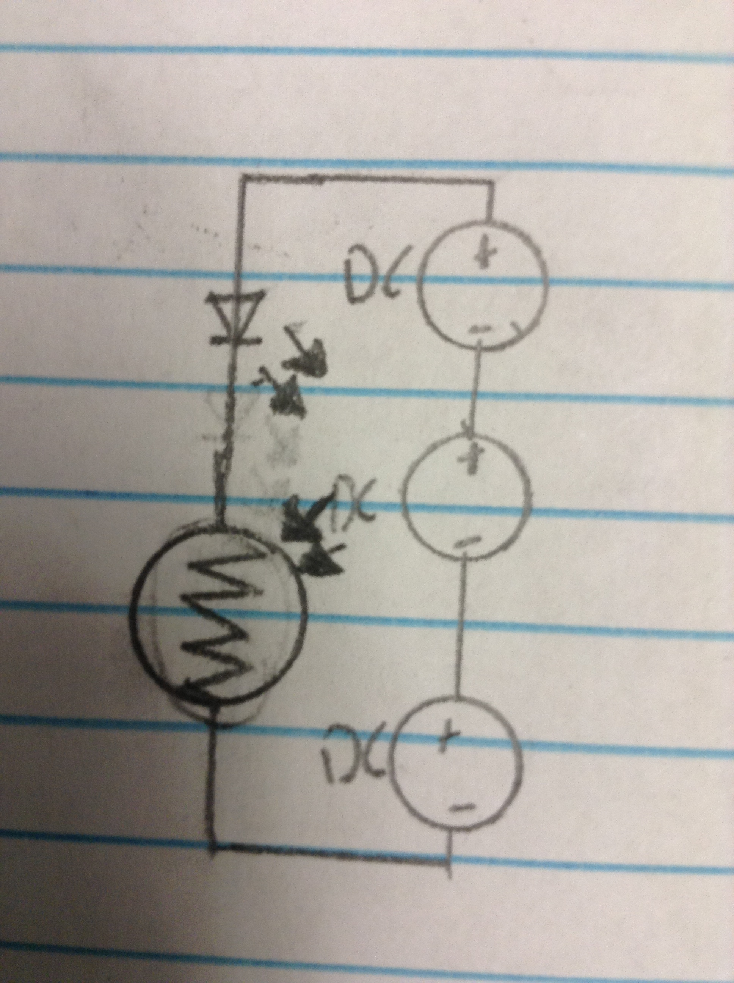

Build your circuit using the Snap Circuits. Then, using the flexible (wire) connectors, attach a lamp to the 6 volt side of the power supply. Power on the circuit. Use the lamp to shine light over the photocell. **EXPLAIN** what is happening to the LED.

The LED is darker when the light in the photo resistor is dark and vice versa because the resistance is higher in the dark and lower in the light.

**Conclusion**

1. Describe a situation where using a potentiometer would be useful.

In screen brightness, a potentiometer can be used to make a circuit have more resistance and dim a screen or vice versa.

1. Describe a situation where using a thermistor would be useful.

On cars, trucks, or buses use thermistors to indicate whether the oil and coolants are at the right temperature. When the thermistors get too hot, they have less resistance and turn on lights on the dashboard.

1. Describe a situation where using a photocell would be useful.

In nightlights, a photocell could be used to turn on the light when the room is dark and turn off when it’s not needed.